**September 12, 2014 Inventorying**

**From the JMM Handling Guide (Sep 2014)**

**Collections Inventorying**

In a collection used as heavily as the Joseph Moore’s inventorying the collection is an ongoing function. “Inventorying” is essentially visually identifying a specimen to confirm that it is still present in the collection in its proper location.

In the picture below on the right side of the collections object record, there is a window for “Inventory Date.” This is updated manually during the cataloging process and any time a collection inventory is conducted. The date entered is the last “official” time a specific item was seen.

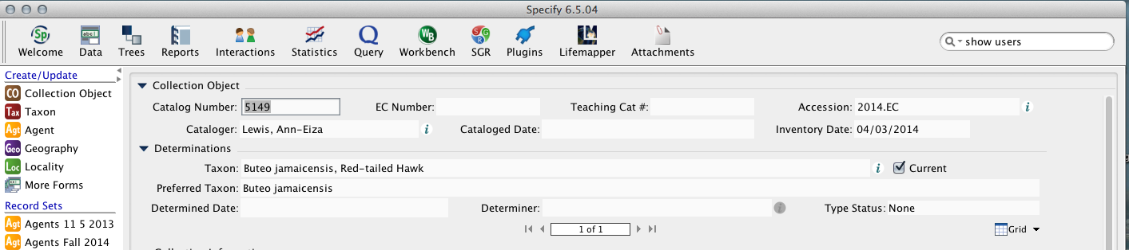

**Steps to Inventorying at JMM using Specify**

**☐ Enter any data from the label that is missing in specify**

**☐ Change any data in Specify** that doesn't match the label🡪Keep in mind that the label is the source and Specify is the copy. Do NOT make changes to the labels! That is, Specify should match the label, not the other way around.

**☐ Check that the Geography** is entered correctly. That is, as much information as is possible is selected from the geography field, rather than hand-entered in the locality field.

**☐ Enter today’s date in the “inventory date”** field at the top right of the collection object form

**Steps to Inventorying at JMM using Specify**

**☐ Enter any data from the label that is missing in specify**

**☐ Change any data in Specify** that doesn't match the label🡪Keep in mind that the label is the source and Specify is the copy. Do NOT make changes to the labels! That is, Specify should match the label, not the other way around.

**☐ Check that the Geography** is entered correctly. That is, as much information as is possible is selected from the geography field, rather than hand-entered in the locality field.

**☐ Enter today’s date in the “inventory date”** field at the top right of the collection object form

**September 12, 2014 Inventorying**

**From the JMM Handling Guide (Sep 2014)**

**Collections Inventorying**

In a collection used as heavily as the Joseph Moore’s inventorying the collection is an ongoing function. “Inventorying” is essentially visually identifying a specimen to confirm that it is still present in the collection in its proper location.

In the picture below on the right side of the collections object record, there is a window for “Inventory Date.” This is updated manually during the cataloging process and any time a collection inventory is conducted. The date entered is the last “official” time a specific item was seen.

